

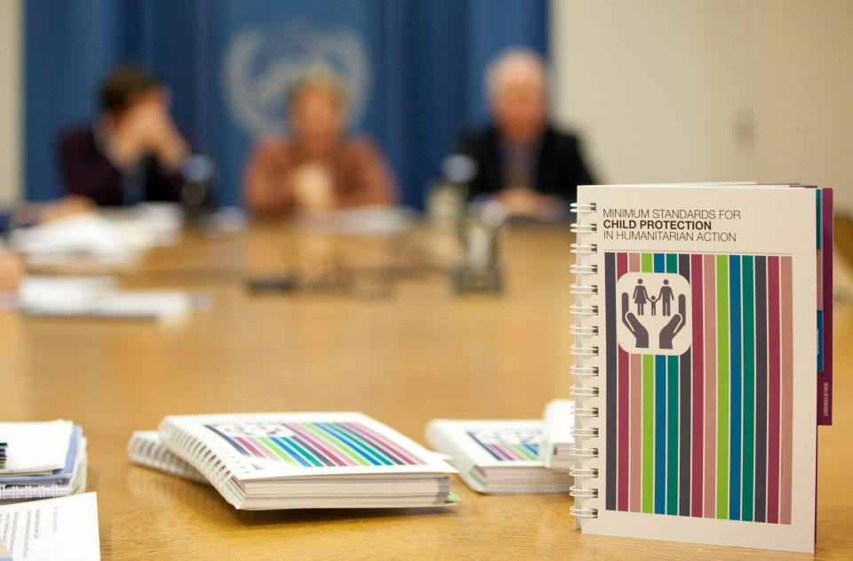

INTRODUCTION TO THE CPMS

FOR FRONTLINE, COMMUNITY WORKERS

TRAINING NOTES – 2014 V1

GENERAL OVERVIEW

This training has been designed as an interactive, participatory experience that depends upon the thoughts, feelings, beliefs, values and experiences of participants to guide the learning about how to effectively implement the Minimum Standards for Child Protection in Humanitarian Action (CPMS) in a given context.

The overall Purpose of the CPMS is

* To establish common principles amongst those working in child protection, and to strengthen coordination between them
* To improve the quality of child protection programming, and its impact for girl and boy children
* To improve accountability within child protection work
* To further define the professional field of child protection
* To provide a synthesis of good practice and learning to date
* To enable better advocacy and communication on child protection risks; needs and responses

RECOMMENDED AUDIENCE

This Workshop is intended for use by Child Protection Managers with their front-line staff.

The activities assume an established relationship between the CP Manager and staff with activities that assist in demarcating the learning environment from the regular working environment. Emphasis is on creating a safe learning space wherein national staff’s expertise in cultural beliefs, values and child protection practice is explored and utilized as the foundation from which to build approaches that will effectively implement the CPMS in a given context.

Ideally, the number of training participants would not exceed a ratio of more than 20 participants for each trainer/facilitator.

TIMING

The training is to be used primarily in the context of Emergency Preparedness as AN INITIAL 2 DAY EVENT, followed by ADDITIONAL 1-DAY OR HALF-DAY WORKSHOPS (at a rate to be determined by the programs) that use field experience as a means to share lessons learned and refine activities and indicators towards improved implementation of the CPMS.

LEARNING OUTCOMES

* To raise awareness and generate understanding of the CPMS
* To identify existing contextual mechanisms that support implementation of the CPMS
* To identify contextual challenges to implementation of the CPMS
* To begin to identify indicators to implement the CPMS

UNDERLYING THEORY TO APPROACHES

The training acknowledges how complex it can be for a program or community to consider implementing the CPMS. The recommended activities demonstrate the importance of understanding the cultural beliefs, values and norms of a given context that guide current practice with girl and boy children and their protection, as a first step towards creating space to introduce the CPMS. National staff are the most important group with whom beliefs and values must be explored, as all program objectives and goals are achieved through their work. The training is built upon the understanding that information does not change behaviour, but rather honest dialogue, reflective of integrity and a willingness to co-create context-appropriate approaches is the best possible means to achieve implementation of the CPMS. This approach also helps to avoid the fragmentation that can arise when national staff are forced to adopt foreign standards without adequate time and investment in reflecting on both the existing mechanisms that can support these standards and the potential barriers to implementation.

To establish this entry point, and create an environment conducive to learning for all participants, (trainer/facilitator included) adequate time must be spent in the session entitled Group Norms to develop a sense of safety among participants. There is much at stake for National Staff in any training, and the ability to speak honestly about beliefs, values and practices towards girl and boy children is dependent upon mitigating the risk (cultural, community, employment) that participants feel about sharing, by allowing them time to make *explicit*, those aspects of communication that both hinder contribution and enhance the potential for it. This is **vital**, and is the reason for the allotted time to this session. The foundation of all other sessions is built upon this opening session.

KEY TRAINER CHARACTERISTICS AND SKILLS

Child Protection Managers facilitating this training need to utilize excellent active listening skills; including questioning, clarifying, reflecting and specifically asking participants ‘how’ they know what they know, towards deepening self-awareness, integrating new material and defining indicators that will alert them to changes that can be linked to the CPMS. Recognizing that tension and conflict are natural parts of learning processes such as these, and handling them when they arise will create an environment wherein dialogue about how the CPMS can be implemented can take place.

OUTLINE OF THE TRAINING

The training has been developed in a session order but depending on the priorities of the specific training you are delivering you can easily adapt and change the order.

**SESSION 1 – INTRODUCING THE MINIMUM STANDARDS FOR CHILD PROTECTION IN HUMANITARIAN ACTION AND ESTABLISHING NORMS**

To welcomes and introduce participants to each other.

**SESSION 2 – EXPLORING BELIEFS AND VALUES RELATED TO THE CPMS**

To make explicit, existing beliefs, and values about children in context that may support or challenge implementation of the CPMS.

**SESSION 3 – CHILD PROTECTION IN EMERGENCIES OVERVIEW (ALTERNATIVE SESSION)**

To introduce Child Protection to the group and initiate thinking about Child Protection in context; to help make the distinction between children’s rights and Child Protection. To educate the group on the definition and meaning of Child Protection and Child Protection in Emergencies.

**SESSION 4 – CHILD PRTOECTION RISKS INTRODUCTION TO THE CPMS**

To build existing participant knowledge of context, of systems, of issues related to CP and the CPMS and identify the priority Standards on which to base the discussion of the CPMS.

**SESSION 5 – INTRODUCTION TO THE CPMS**

To provide an overview of the development of the CPMS, its purpose and content.

**SESSION 6 – CPMS CASE STUDY: AN IN-DEPTH LOOK AT THE CPMS**

To deepen the understanding of the CPMS and how to use it through a programmatic case study; to provide an opportunity for participants to use the CPMS handbook.

**SESSION 7 – MAINSTREAMING STANDARDS**

To increase understanding of the purpose of the Standards to Mainstreaming Child Protection.

**SESSION 8 – IMPLEMENTING THE CPMS IN THIS CONTEXT**

To introduce the Measurement section of the CPMS and facilitate initial understanding of the role of indicators. To provide participants with an opportunity to engage practically with the CPMS in a way that fits with their context. To practically highlight the existing mechanisms that support or challenge CPMS implementation in their community.

**SESSION 9 – FOLLOW UP PLANS AND CLOSURE**

To share with participants the plans for follow-up to the CPMS Workshop.

**SESSION 10 – FOLLOW UP WORKSHOP**

To reflect on challenges and successes in implementing the CPMS in the context. To further work on understanding and developing indicators from the CPMS:

**Sample Workshop Outline – 2 DAY WORKSHOP**

|  |  |  |
| --- | --- | --- |
| **Session** | **Methodology** | **Timing (to be adjusted to context)** |
| **DAY ONE** | | |
| Session 1: Introduction to the training and establishing group norms | Presentation; group discussion | 1hour 15 min (9-10:15) |
| Break |  | 30 min (10:15 – 10:45) |
| Session 2: Exploring beliefs about boy and girl children related to the CPMS | Individual activity; group discussion | 1h 15 min (10h45-12:00) |
| Lunch |  | 1 hour (12-13) |
| Session 3: Child Protection in Emergencies (optional session) | Group discussion | 40 min (13-13:40) |
| Session 4: Child Protection Risks in the Communities | Small group work; group discussion | 40 min (13:40 – 14:20) |
| Break |  | 30 min (14:20-14:50) |
| Session 5: Introducing the CPMS | Presentation with questions and discussion | 60 min (14:50-15:50) |
| Session 6: Case Study on the CPMS | Case study; small group discussions | 60 min (15:50 – 16:50) |
| Session 7: Mainstreaming Standards | Large group discussion | 20 min (16:30-16:50) |
| Day 1 Check Out Activity |  | 10 min (16:50-17:00) |
| **DAY 2** | | |
| Day 2 Check In Activity |  | 15 min (9-9:15) |
| Recap of Day 1 |  | 15 min (9:15-9:30) |
| Session 7: Mainstreaming Standards | Large group discussion | 30 min (9:30-10) |
| Session 8: Implementing the CPMS in this Context – Indicators | Discussion in pairs, large group discussion | 30 min (10-10:30) |
| Break |  | 30 min(10:30-11) |
| Session 8: Implementing the CPMS in this Context – Practical Plans | Small group work | 1 hour 30 min (11-12:30) |
| Lunch |  | 1 hour (12:30 -14) |
| Session 8: Implementing the CPMS in this Context (Cont.) – Practical Plans | Presentations and discussions | 1 hour min (14 – 15) |
| Session 9: Follow up Plans and Workshop Closure |  | 1 hour 15 min (15-16:15) |

**Sample Workshop Outline – 1 DAY FOLLOW UP WORKSHOP**

|  |  |  |
| --- | --- | --- |
| **Activity** | **Time (to be adjusted to context)** | **Purpose** |
| Welcome and introduction to the workshop | 10 min (9 – 9:10) | Open the workshop |
| Review Group Norms and Brainstorm Expectations | 20 min (9:10 – 9:30) | To re-establish norms for good communication, reminder of objectives and agenda |
| Discussion on Indicators | 60 min (9:30-10:30) | To increase understanding of identifying indicators and measuring child protection work |  |
| Break | 15 min (10:30-10:45) |  |
| Reflection and case study preparation in small groups | 90 min (10:45 – 12:15) | To reflect on practical experiences of implementing CPMS to-date  To identify successes, support and challenges to CPMS implementation |
| Lunch | 60 min (12:15 – 13:15) |  |
| Group Presentations of case studies | 90 min (13:15-14:45) | To reflect on the experiences of attempting to use the CPMS to date |
| Break | 15 min (14:45 - 15) |  |
| Revision of indicators | 45 min (15 – 15:45) | To make adjustments to indicators as needed in line with re-worked strategies from the previous session |
| Check-out activity | 30 min (15:45 –16:15) | To share learning from the day |
| Workshop evaluation | 10 min (16:15-16:25) | To evaluate the workshop to identify what worked and what can be improved upon |
| Workshop Close | 5 min (16:25-16:30) | To officially close the workshop |

ICONS / PROMPTS USED ACROSS TRAINING –

These icons / prompts will be used throughout training notes and are also on the presentation slides as reminders for you and participants of what is to come and actions needed.





Guest Speaker or Presentation Handout to be given





Activity Time Tag key document and / or course book





Group Reflection / Break Point Large and Small group discussions





Syndicate / Small Group Work Reading Activity





DVD / Video link Butchers Paper exercise

j0205582



Computer Activity Refer to reference or key document

Flashback / Reminder to





Question to the group other parts of the training

[](http://www.google.com.au/url?sa=i&rct=j&q=&esrc=s&frm=1&source=images&cd=&cad=rja&docid=KXtcHy-Q59S8IM&tbnid=Gp645ZxbG-8kzM:&ved=0CAUQjRw&url=http://dribbble.com/iljamiskov/projects/86525-Secret-App&ei=hKV4UaasIKiRige504HAAQ&bvm=bv.45645796,d.aGc&psig=AFQjCNGt_vbsfdaQZV9P2oHLMIMt3bkO3g&ust=1366947574678702)

Trainer -Handy Hint

PREPARATION PRIOR TO TRAINING – SET-UP CHECKLIST

General for trainer / organiser:

* Training direction signs to training room
* Registration list and table name tags / signs
* Training notes for trainer / organiser only
* USB (with up-to-date power points)
* Tissues
* Pens
* Blu Tac or Tape
* Butcher’s paper / flip charts and stand
* Note cards in various colours for use in activities
* Trainers pack incl: whiteboard markers, pens, tags, blu tac etc
* IEC posters and materials from local area / country re: CPIE
* Training rapporteur
* Training room – LCD, screen, whiteboard, flip charts (enough for 5 small groups), wireless internet

For Participants:

* Notebooks
* Copies of the CPMS Handbook
* Session Handouts
* Folder for each participant to put resources in
* Hole puncher and stapler

Trainer to:

* Ensure draft suggested agenda is adjusted and designed, in advance, with the organisers of training
* All PowerPoint’s are saved on thumb drive / USB in line with new agenda, in day folders, for easy use and saving for participants
* Ensure they have read and understand all materials in the training package including all activity handouts and key resources
* Ensure they have their own training folder with all resources tabbed
* Make sure all technology is working in the room ie: internet and projector – prior to start of training.
* Place all materials and resources are placed on the tables prior to participant arrival
* Place name tags or table locations are adjusted so that participants, where possible, sit next to someone they don’t know.
* Create posters using flip chart paper and place on wall for: ‘parking lot’; acronyms; and learning agreement.