

SESSION – 1 – PLAN FACE SHEET

|  |  |  |  |
| --- | --- | --- | --- |
| TRAINING COURSE: An Introduction to the CPMS | | | SESSION 1: Introduction and Establishing Group Norms |
| TIMING: 1 hour 15 minutes | | VERSION: 1 | DEVELOPER: CPMS Task Force |
| SESSION Aim:   * To officially open the workshop and as such demarcate the space between the regular work environment/relationships and the workshop/learning space. * To give participants a brief overview of the overall objectives of the workshop and provide a plan for the 2 days. * To create an environment wherein participants can engage in safe learning practices that emphasize honesty and risk-taking; to encourage relationship building and teamwork between staff members; to establish trust, diminish implied power structures and generate communication styles and norms that can be called upon in the event of conflict   SESSION LEARNING OUTCOMES:   * Summarise the outline of the training * Develop clear participant expectations * Establish a learning agreement   SESSION ActivitIES:   * Introduce yourself, the participants and welcome everyone to the workshop. * Using the flip chart, verbally take participants through the key objectives of the workshop and the outline for the 2 days of activities. * Establish group norms through a group brainstorming.     child protection Minimum STandardS: n/a  CPIE COMPETENCY FRAMEWORK: N/A | | | |
| REFERENCE(S): Minimum Standards for Child Protection in Humanitarian Action | | | |
| RESOURCE(S): | Flip Charts, Marker Pens  Powerpoint **(optional)** | | |

SESSION 1 – LESSON PLAN –

INTRODUCTION AND ESTABLISHING GROUP NORMS

|  |  |  |  |
| --- | --- | --- | --- |
| TIME | 1 HOUR 15 MIN | | |
| **\* RESOURCES REMINDER \*** | | | |
| [http://officeplusfurniture.com.au/wp-content/gallery/flipchart/accessories04-4.jpg](http://www.google.com.au/url?sa=i&rct=j&q=&esrc=s&frm=1&source=images&cd=&cad=rja&docid=WcaclcEQIoQnxM&tbnid=crnc3ov1B8UjVM:&ved=0CAUQjRw&url=http://officeplusfurniture.com.au/products/visuals/flipcharts/&ei=w02AUtqnMcPTkAXYioDYCQ&psig=AFQjCNFKI8L1OVP6Mj5HDDCSU7IjHkHm7w&ust=1384226617784617) | * Have the key objectives written on a flip chart sheet that you can use to walk through an overview of the objectives and activities. * Have a flip chart sheet prepared with the words Group Norms written on it and record answers and then post the sheet on a wall where everyone can see it. * Have 3 flip chart sheets on the wall with the titles Acronyms, Car Park and Learning Agreement prepared. | | |
| **INTRODUCTION** | | | |
| 2 min | * Welcome everyone to the training. | | |
| **BODY** | | | |
| 10 min | Special guest speaker. This speaker should be senior level from within the government or hosting organization. They should be expressing the importance of the CPMS and its application in the context. | |  |
| 25 min | Check-in Activity – ‘If you could be…’ or other participant introduction activity of your choice | |  |
| 20 min | Group Norms Activity | |  |
| 10 min | Learning Agreement | |  |
| 5 min | Car Park, Admin and Acronyms | |  |
| **CONCLUSION** | | | |
| 3 min | O | So that session gives you a quick overview of the training to come and you have clearly communicated your expectations which we will do our best to meet. | |
| F | This is a good start to the day recognising that this workshop, while short, is extensive and each day is packed full. | |
| F | Next session we will look at values and beliefs in this context that will underlay the application of the CPMS. | |

**SESSION 1 – NOTES FOR TRAINER – INTRODUCTION AND ESTABLISHING GROUP NORMS**

|  |
| --- |
| LEARNING OUTCOMES   * Summarise the outline of the training * Develop clear participant expectations * Establish a learning agreement |

Welcome participants to the training.

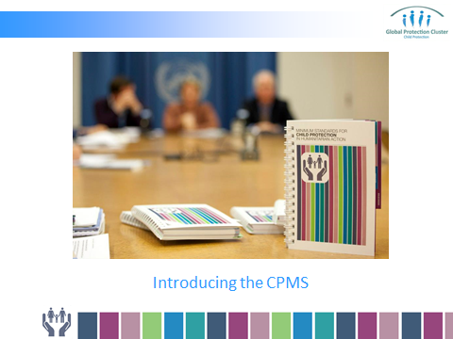

Make the room feel relaxed and happy.

Introduce the guest speaker and / or organiser to introduce guest speaker.



**HANDY HINT -** *Ensure you have met with both the organiser and speaker prior to the training to make sure it is clear how this introduction will proceed including if the guest speaker will stay for the entire introduction or will leave after their speech.* *Cultural considerations should also be discussed.*

[](http://www.google.com.au/url?sa=i&rct=j&q=&esrc=s&frm=1&source=images&cd=&cad=rja&docid=KXtcHy-Q59S8IM&tbnid=Gp645ZxbG-8kzM:&ved=0CAUQjRw&url=http://dribbble.com/iljamiskov/projects/86525-Secret-App&ei=hKV4UaasIKiRige504HAAQ&bvm=bv.45645796,d.aGc&psig=AFQjCNGt_vbsfdaQZV9P2oHLMIMt3bkO3g&ust=1366947574678702)

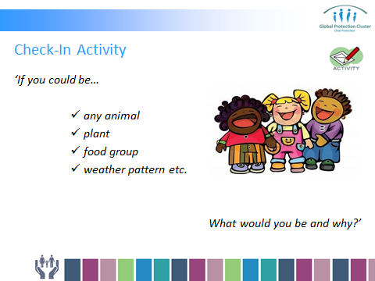

Even though the assumption is that there is relationship between the CP Manager and staff, it is important to differentiate the learning space through actions such as this. This may take less than the allotted time if there aren’t any questions about the objectives.

**PURPOSE OF ACTIVITY** – To move people out of their ordinary roles, to get them thinking about themselves and each other and to emphasise that the work together needs to be purposeful and fun.

**CHECK-IN ACTIVITY** – Ask participants to take turns stating their names and answering the following question: *‘If you could be… any animal (or plant, or food group, or weather pattern etc.) What would you be and why?’*





Trainer(s) and organisers should also introduce themselves and answer the question *‘if you could be…’* too.

Ask for the reasons behind the choices if they are not readily given in the response. This will give insight into the values that a particular person holds or aspires to.

Ask for clarification as needed and summarise each person’s response so they feel heard and finished. Example: “So for you, who chose to be a lion, leading and being strong are important?”

**GROUP NORMS ACTIVITY –** Introduce Group Norms as the first step to creating safe space for people to share.



**PURPOSE OF ACTIVITY** – To create an environment wherein participants can engage in safe learning practices that emphasize honesty and risk-taking; to encourage relationship building and teamwork between staff members; to establish trust, diminish implied power structures and generate communication styles and norms that can be called upon in the event of conflict.

Participants are asked to define the behaviours, communication styles, actions and gestures that help them feel safe to contribute and/or those that shut them down.

Help participants be as specific as possible by asking for clarification of their responses.

Use the following questions as guides to drawing out this important information and record the answers on a flip chart sheet that can be posted in the room and referred to at any time.

**Examples of questions:**



* What helps you feel like you can speak honestly?
* How do you know when you feel safe to participate?
* What tells you when you don’t?
* What shuts you down?

Use examples such as the need for respect, judging, being laughed at, interrupting, shouting etc. to draw out responses and be mindful of your own assumptions as some communication styles assumed to be unacceptable in one context are quite acceptable in another.

This is the foundation for everything that follows. It is often under-valued. Participants really need to spend time discussing the things that help them share and stop them from doing so, even if they are uncomfortable about having that conversation in the first place.



**Be patient;** everything that happens in a group is useable. If there is silence, ask what that is about, if there is discomfort, say so; make it explicit and use it. What is difficult about answering the question *‘what shuts you down or helps you feel safe to talk’*?

If participants are reluctant to share at this stage, they will be reluctant to share their beliefs and values about girl and boy children, upon which the whole training is dependent.

Record answers as they are provided and ask for clarification on all responses rather than assuming you understand what has been said. Ask for examples where possible to get as detailed a list of group norms as possible. This list will be used as a reference if conflict arises.

For example in Sierra Leone, it was quite acceptable to most staff to have other staff members laugh as they recounted painful stories of loss and trauma. In the other contexts this might be grounds for serious conflict but in this context, it was welcomed by the speakers as a means of lightening the heaviness of the experiences.

Building on from above, also create a learning agreement to finish out the session.

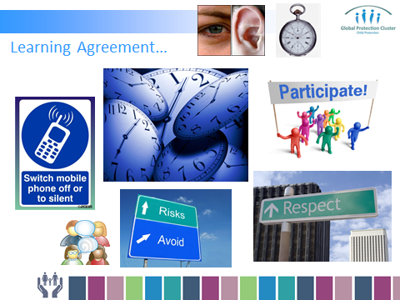

The learning agreement between trainer and participants provides a context to learning and facilitates a safe, open and transparent learning environment that is established through a mutually agreed set of expectations regarding individual and group learning and general behaviour throughout training.

The trainer should open discussions on what ‘rules’ the participants feel are important to foster a quality learning environment. As they make suggestions trainer to put up on flip chart paper. If you have two trainers, one trainer to scribe these on the prepared flip chart paper, whilst second trainer facilitates discussion. If not ask a participant to assist. Suggestions could include:

* Mobile phones off/silent and not to text or use social media during sessions.
* Punctuality
* Commitment to break times
* Attendance at all sessions (unless unwell)
* Listening/no interrupting
* Respect other’s opinions
* Participation
* Take Risks
* Ask questions
* Computer use
* Confidentiality
* Self Care Message
* No smoking

Throughout the process challenge ideas and concepts around these words so there is clear ownership and understanding. At the end ask participants again for any additional expectations they wish to add. Focus specifically on expectations they have of each other.

Don’t forget any housekeeping / administration information. This is not part of the agreement but needs to be discussed at this stage. The organiser should also assist. Some areas to think of:

* Location of toilets
* Smoking areas
* Fire alarms and exits
* Breaks
* How lunch will be presented and where
* Coffee / tea
* Security cards etc.



Point out the parking lot which should be a prepared flip chart in a prominent place.

To assist in keeping us all on time, key issues, questions and / or areas that are not being addressed or can’t be addressed in a session will be placed there so that it is not forgotten and will be addressed by the end of the training.

At this stage ask for *a time keeper volunteer* from the participants to assist in everyone staying on time.



*Any further comments and / or questions… ?*



|  |  |  |
| --- | --- | --- |
| **CONCLUSION** | | |
| 3 min | O | So that session gives you a quick overview of the training to come and you have clearly communicated your expectations which we will do our best to meet. |
| F | This is a good start to the day recognising that this workshop, while short, is extensive and each day is packed full. |
| F | Next session we will look at values and beliefs in this context that will underlay the application of the CPMS. |