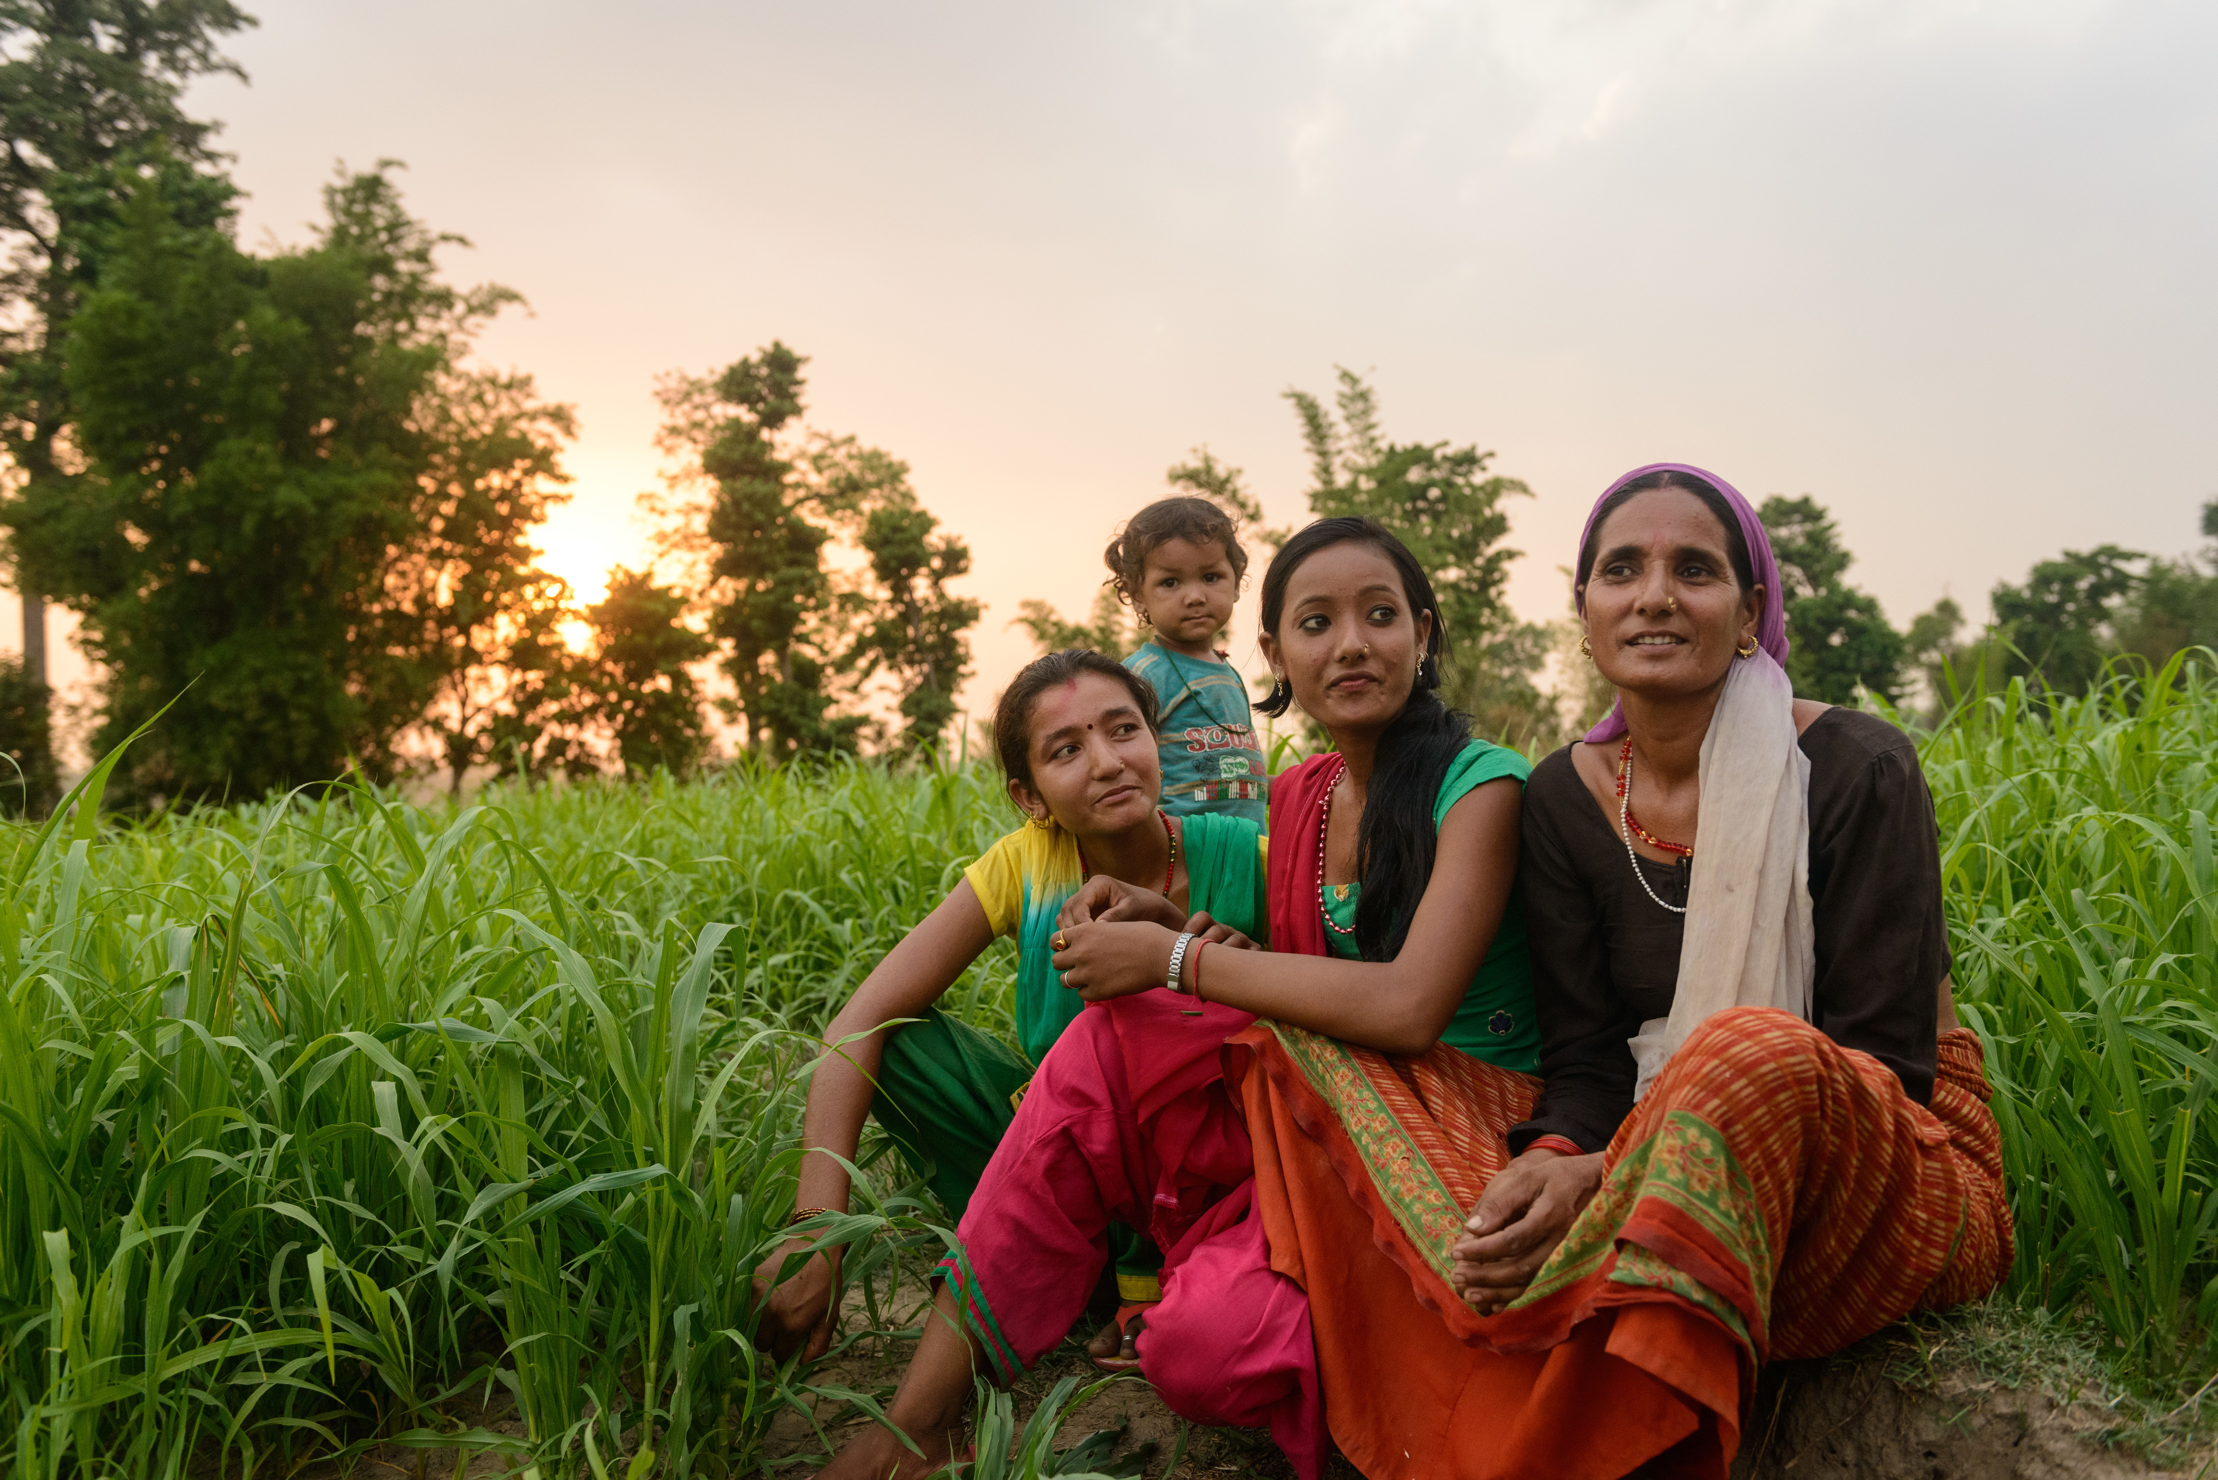

**GirlSPARKS Asia & the Pacific Regional Training**

**Application Form**

Thank you for your interest in the upcoming GirlSPARKS training in Bangkok, Thailand, from 29th April - 1st May 2019.

Our interactive training workshops are best suited to a group of no more than 25 participants. Due to high demand, we are expecting more applications than there are places available. We are therefore looking for highly motivated applicants who can demonstrate their commitment to the training and subsequent application of learning.

At the end of the form, all applicants will need to provide confirmation from their line manager that they are authorised to attend this training, and that their organisation will cover their participation fee, expenses, travel and accommodation.

APPLICATION PROCESS

We are accepting applications until **April 15th 2019** for our Asia-Pacific Regional Training in Bangkok.

1. Return your application form with the required signatures
2. We will send you an invoice for the training
3. Provide proof of payment and your registration will be confirmed! We will then send you a pre-training survey and a participant pack with logistical information about the training.

PARTICIPANT FEE

GirlSPARKS aims to support national Non-Governmental Organisations (NGOs) and Community-Based Organisations (CBOs) to access our services. To this end, we will be using a progressive pricing scale to enable smaller organisations to attend our training.

We also offer a discount for participants whose registration is confirmed by **15th March 2019**. Participant registration will be confirmed once GirlSPARKS receive the participant’s completed application form and subsequent proof of payment of the invoice.

The participation fee includes:

* Three-day Girl-Centred Design training
* Training materials
* Daily lunch and coffee breaks
* Certificate of participation
* Girl-Centred Design participant toolkit
* Follow-up coaching
* Access to all GirlSPARKS resources, including community of practice

|  |  |
| --- | --- |
| **Early bird fee (by 15th March 2019)** | **USD 500** |
| Standard fee **\*** | **USD 625** |

**\*GirlSPARKS offers reduced fees to enable local and grassroots organisations to attend our training. Please select NGO/CBO in section two if this applies to you, and email us with any questions at** [**info@girlsparks.org**](mailto:info@girlsparks.org)**.**

Please note that **the fee does not include accommodation, expenses and travel costs**, but that the training venue will provide negotiated rates for training participants.

PAYMENT

The participation fee should only be paid once the applicant has received an invoice from Mercy Corps.

Mercy Corps accepts bank transfers and credit cards (VISA, MasterCard and Maestro). All bank charges and commissions are paid by the participants. Payment on site is not allowed.

APPLICATION

|  |  |
| --- | --- |
| **Section 1: Personal Details** | |
| Name | **Click or tap here to enter text.** |
| Organisation | **Click or tap here to enter text.** |
| Job title | **Click or tap here to enter text.** |
| Nationality | **Click or tap here to enter text.** |
| Languages Spoken | **Click or tap here to enter text.** |
| Email | **Click or tap here to enter text.** |
| Contact phone number | **Click or tap here to enter text.** |
| Any requirements? (e.g. disability access, dietary) | **Click or tap here to enter text.** |
|  |  |
| **Section 2: Organisation Size & Participation Cost** | |
| Please choose the size of your organisation. | **INGO/NGO/CBO** |
|  |  |
| **Section 3: Programming & Motivation** | |
| Why are you applying to attend this Girl-Centred Design training? (maximum 150 words) | **Click or tap here to enter text.** |
| Does your work currently involve implementing programming with a focus on girls? | **Yes/No.** |
| **If yes**, please provide a short description of the programme focusing on girls and its aims (max 150 words). | **Click or tap here to enter text.** |
| **If no**, are you planning to implement programming with a focus on girls in the future? If so, please provide a short description of the proposed programme. | **Click or tap here to enter text.** |
|  |  |
| **Section 4: Commitment and Availability** | |
| Are you free to attend the full training from 29th April – 1st May? | **Yes/No.** |
| If no, please outline which part you are available to attend | **Click or tap here to enter text.** |
| How are you hoping to use a Girl-Centred Design approach following the training? (max 150 words) | **Click or tap here to enter text.** |
| After the training, are you willing to participate in a follow up call with the GirlSPARKS team to discuss translating learning into practice? | **Yes/No.** |
|  |  |
| **Section 5: Comments & Questions** | |
| Do you have any comments or questions for the GirlSPARKS team? | **Click or tap here to enter text.** |
|  |  |
| **Section 6: Organisational Commitment** | |
| **Participant signature:**  I **Participant Name** confirm that I am available to attend the Girl-Centred Design training in Bangkok, Thailand, from 29th April – 1st May 2019  Name: **Click or tap here to enter text.**  Date: **Click or tap here to enter text.**  **Organisational signature:**  I **Line Manager/ Senior Manager Name** of **Participant Name** confirm that **Participant Name** has permission to attend the GirlSPARKS training in Bangkok, Thailand from 29th April – 1st May 2019, and that their participation fee, travel and accommodation will be provided for.  Line Manager Name: **Click or tap here to enter text.**  Line Manager Email: **Click or tap here to enter text.**  Job title: **Click or tap here to enter text.**  Date: **Click or tap here to enter text.** | |



Thank you for completing this application form, please return it to [info@girlsparks.org](mailto:info@girlsparks.org) with the required signatures.

**The GirlSPARKS Team**