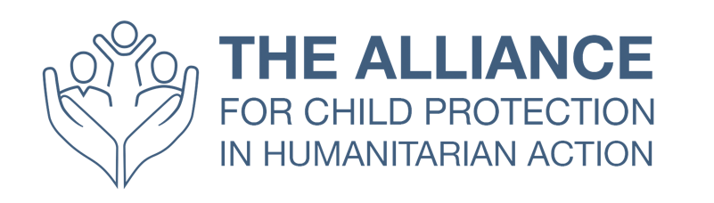
Child Protection in Humanitarian Action: Frontliner’s
Getting Started Learning Package
Participant Handout

This handout contains the key messages from each session in the training course and is meant as a reference document to support your learning and use of the knowledge gained in the course, in your role. For more details on Child Protection in Humanitarian Action, you can refer to the Minimum Standards for Child Protection in Humanitarian Action (CPMS).

Session 1: The Child
- The terms child and children refer to all children and young people from birth to 18 years of age, as specified in the UN Convention on the Rights of the Child.
- Child Development is the process of individual growth and maturation from birth to adulthood. It concerns the physical, cognitive, emotional, and social changes that occur in all children and young people as they grow older. (See supporting information for more details.)
- As children develop from infants to adolescence, they go through different developmental stages and achieve developmental milestones; abilities that most of the children achieve by a certain age. While age groups can vary according to context and culture, developmental stages are often organised into:
  - Early Childhood: 0 to 6 years of age and, within this, infancy from 0 to 12 months, 1 to 3 years of toddlerhood age, 4 to 6 years pre-school age
  - Middle Childhood: 7 to 12 years of age
  - Adolescence: 13 to 17 years of age
- It is important to learn about children’s development in order to:
  - understand children’s needs, reactions, and coping strategies
  - understand how children face crises
  - support caregivers to respond appropriately to children’s reactions according to their developmental needs
  - understand the basic needs of boys and girls
- Many factors influence children’s development and well-being. Some of these factors are internal to the child and some are external. The external factors represent the child’s world, which is like a spider web. The child sits at the centre but feels what happens in any parts of the web and plays an active role in their own development, depending on personality and temperament. When we talk about a child’s environment we talk about the child’s social web. The child’s environment/spider web can be represented with a diagram with the child at the centre, surrounded by a number of rings that represent things that can affect their life. This is called the Socio-Ecological Model, which is an approach that helps illustrate the interaction between internal and external factors. That is to say, the interaction between internal (psychological) and the outer (social) world of the child.
  - The closest ring to the child represents the immediate family, which has the biggest influence on children’s physical, cognitive, emotional, and social development
  - The next ring would be represented by the extended family and the closest social networks: This includes family members, neighbours, cultural groups, and other groups interacting with children
  - After this circle there is the community with school, community, playgrounds, child social and health services, and other community services (cultural groups, neighbours, etc.)
  - Society involves the broader economic, political, cultural, and social context, including: the financial situation, conflict, poverty as well as the legal framework and policies
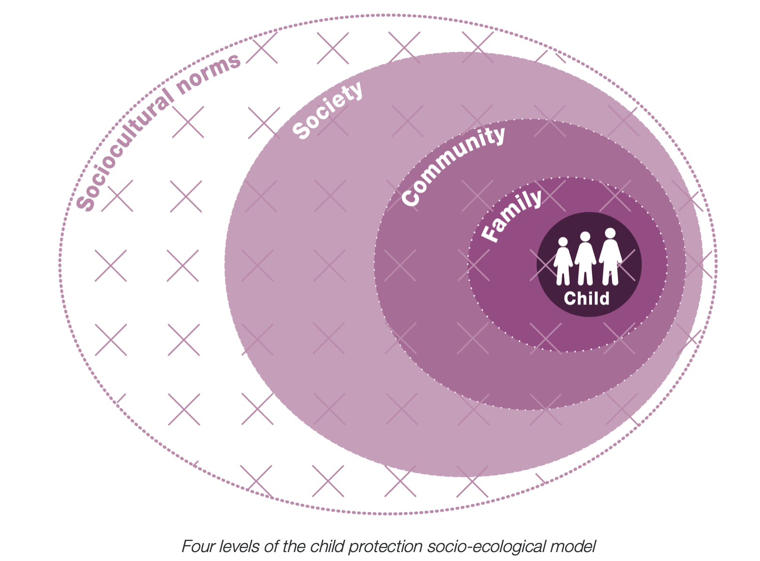
- The Socio-Ecological Model also illustrates that risks and protective factors exist at all levels of children’s safety and well-being. Protective factors are those factors in children’s lives that enhance their healthy and positive development. Risk factors are those factors in children’s lives that interfere with their development and make them more vulnerable. All of our efforts when working with children and young people should aim to reduce risk factors and strengthen protective factors. Adults who have positive interactions with children represent a protective factor. Risk and protective factors are different at different stages of children’s development, and these may also change when there is a change in the context. During the time of crisis, most of the components of a child’s environment are negatively impacted.
- Universal Protective Factors include:
  - Caregiving in early life by at least one consistent and responsive caregiver
  - Ability to form and sustain meaningful connections to at least one other person throughout life
  - Ability to regulate emotions
  - Opportunities to develop the capacity for problem solving, learning, and adaptation
  - Opportunities to acquire sequentially growing skills and knowledge, according
to the requirements of culture
  - Access to effective formal and non-formal education
  - Age appropriate opportunities to contribute to family and community well-being
  - A sense of self-esteem and self-efficacy
  - Ability to make/find meaning in life
  - Opportunities to exercise a growing capacity for agency and judgement in the cultural context
  - Participation in culture, ritual, and communal systems of belief, leading to a sense of belonging
  - Hope, faith, and optimism

- Universal Risk Factors include:
  - Premature birth, birth anomalies, low birth weight, or pre- or post-natal exposure
to environmental toxins
  - Lack of caregiving by consistent and responsive caregivers during early life
  - Loss or lack of opportunities to develop the capacity for problem solving, learning,
and adaptation
  - Loss or lack of opportunities to acquire sequentially growing skills and knowledge according to the requirements of culture
  - Unmet basic needs (such as limited access to adequate nutrition, shelter, clean drinking water, clothing appropriate to climate, and medical care)
  - Family separation, either temporary or permanent, due to death or inability to continue care on the part of one or more parents or main caregivers (for instance, as a result of forced removal, incarceration, deportation, armed conflict, extreme deprivation or persecution, injury, or physical or mental illness)
  - Exposure to structural, social, or interpersonal violence (including racism, caste or ethnic discrimination and marginalisation, gender discrimination, state sponsored violence, community violence, family or intimate partner violence, or physical, sexual, or emotional abuse)
  - Lack or loss of access to effective formal and non-formal education
  - Loss of community connections
  - Harmful social or gender norms
  - Absence or the non-enforcement of legal and normative frameworks that are meant to protect children from abuse, neglect, exploitation, and violence
  - Displacement resulting from forced migration or loss of home
- The severity of exposure to adversity is a key element that must be considered when identifying risk and protective factors. This is due to there being a positive relationship of the severity of exposure –either to one extremely traumatic event or to multiple adverse events– and the ability of an individual to cope or adapt. The severity of exposure to harmful outcomes may also be influenced by individual –or compounding– factors, such as: age, gender, disability, and legal status (refugee, internally displaced, migrant, or stateless).
- Learning how to cope with adversity is an important part of healthy development. While moderate, short-lived stress responses in the body can promote growth, toxic stress is the strong, unrelieved activation of the body’s stress management system in the absence of protective adult support. Without caring adults to buffer children, the unrelenting stress caused by extreme poverty, neglect, abuse, or severe maternal depression can weaken the architecture of the developing brain, with long-term consequences for learning, behaviour, and both physical and mental health.

Session 2: Child Protection in Humanitarian Action and its Guiding Principles

- Humanitarian crises can be caused by humans, such as conflict or civil unrest; they can result from disasters, such as floods and earthquakes; or they can be a combination of both. Child protection actors and interventions seek to prevent and respond to all forms of abuse, neglect, exploitation, and violence in these humanitarian contexts.

- Humanitarian crises can have a significant impact on children’s formative years, affecting their survival, growth, and development: the systems working to keep children safe –in their homes, schools, and communities– may be undermined or damaged. Boys and girls may be separated from their families, trafficked, recruited, or used by armed forces and armed groups, be detained, face economic exploitation, be forced into slave-like conditions, and suffer physical abuse and sexual violence.

- Child protection in humanitarian settings is a professional sector which is guided by a number of international, regional, national, and organisational conventions, commitments, and legal and policy frameworks and guidance. It is important to recall:

  - The 1989 United Nations Convention on the Rights of the Child which is the most universally ratified of all international human rights treaties. It provides a comprehensive framework for all states to develop the mechanisms that allow for the delivery of services required for the holistic development of children. The UNCRC recognises the fundamental right of children to be protected from abuse and exploitation, including harmful work (Article 32).

  - The Minimum Standards for Child Protection in Humanitarian Action: in 2010 the members of the global Child Protection Working Group agreed on the need for child protection standards in humanitarian settings. The Minimum Standards for Child Protection in Humanitarian Action (CPMS, or Child Protection Minimum Standards) were finalised in September 2012 and then updated in 2019. These standards set out a common agreement with regards to what adequate quality child protection interventions in humanitarian settings are.

- The principles listed in the CPMS are key to fully applying and achieving the standards. They should be used and presented alongside the standards at all times. Principles 1-4 are the key principles set out by the Convention on the Rights of the Child (UNCRC) and are applicable to all humanitarian action. Principles 5-8 are the protection principles from the 2018 Sphere Handbook, restated here with specific references for the protection of children. Principles 9-10 are specific to the Minimum Standards for Child Protection in Humanitarian Action.
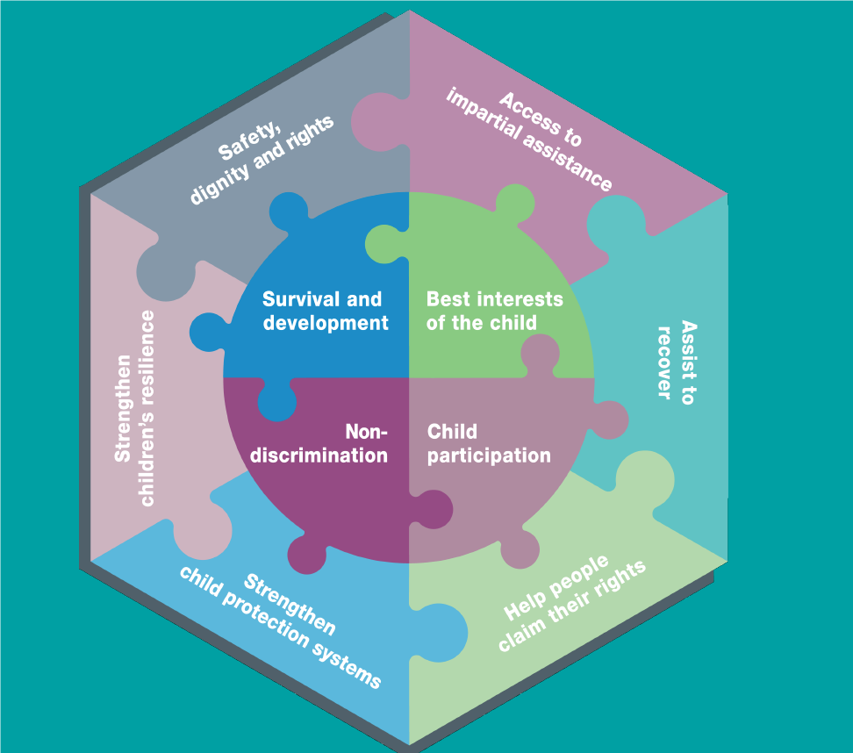
- Principle 1 – Survival and Development: Humanitarian actors must consider the effects of both the emergency and the response on (a) the fulfilment of children’s right to life and (b) children’s physical, psychological, emotional, social, and spiritual development.
- Principle 2 – Non-Discrimination and Inclusion: Children shall not be discriminated against on the basis of gender, sexual orientation, age, disabilities, nationality, immigration status, or any other reason. The causes and methods of direct or indirect discrimination and exclusion need to be proactively identified and addressed. Humanitarian workers must be aware of their own values, beliefs, and unconscious biases about childhood and the roles of the child and the family.
- Principle 3 – Child Participation: Humanitarian workers must provide children with the time and space to meaningfully participate in all decisions that affect children, including during emergency preparedness and response.
- Principle 4 – Best Interest of the Child: Children have the right to have their best interests assessed and taken into account as a primary consideration in all actions or decisions that concern them, both in the public and private spheres.
- Principle 5 – Enhance people’s safety, dignity, and rights and avoid exposing them to further harm: Humanitarian assistance must be provided in ways that reduce the risks that people may face and meet their needs with dignity. Poor design and implementation can lead to unintended, negative risks such as child recruitment, abduction, or family separation.
- Principle 6 – Ensure people’s access to impartial assistance according to need and without discrimination: Humanitarian actors identify obstacles to accessing assistance and take steps to ensure it is provided in proportion to need and without discrimination.
- Principle 7 – Assist people to recover from the physical and psychological effects of threatened or actual violence, coercion, or deliberate deprivation: This principle includes (a) taking all reasonable steps to ensure that the affected population is not subject to further violence, coercion, or deprivation and (b) supporting children’s own efforts to recover their safety, dignity, and rights within their communities.
- Principle 8 – Help people to claim their rights: Humanitarian actors help affected communities claim their rights through information and documentation, and support efforts to strengthen respect for rights.
- Principle 9 – Strengthen Child Protection Systems: Children are rarely exposed to only one protection risk. Vulnerability to one risk can make a child more vulnerable to others. In humanitarian settings, the people, processes, laws, institutions, capacities, and behaviours that normally protect children –the Child Protection Systems– may have become weak or ineffective. The response phase can provide an opportunity to build on and strengthen the many levels and parts of Child Protection Systems.
- Principle 10 – Strengthen Children Resilience in Humanitarian Action: One of the goals of humanitarian actors is to build children’s own strengths by eliminating or reducing risk factors and by strengthening the protective factors that support and encourage resilience. Participation is key to building resilience.

Session 3: Communicating with Children and Communities
- Children need and have a right to clear and interesting child-centred (not adult-centred) communication. Children at different stages have very different needs and interests and learn in different ways.

- It is important that we do not position ourselves as experts when we approach communities, but rather as facilitators of shared efforts to protect their children, and open to learning from communities being experts in their own lives. Acting as a catalyst or facilitator can enable shared discussion, decision making, and consensual actions.

- Effective facilitators are:
  - Learners: humble, open to new ideas, flexible to new ways of doing things, willing to build on existing knowledge with new information, do not judge the community they are working with, etc.

  - Listeners: attentive, engaged, curious, patient, emphasising dialogue and not lectures

  - Negotiators: open to tension, can understand and manage power dynamics, willing to see different sides of issues, gently persuasive, comfortable not controlling the discussion, and committed to positive outcomes for all participants with a specific focus on age, gender, and inclusion dimensions

  - Observers: sensitive to non-verbal cues/body language, interpersonal dynamics with a specific focus on age, gender, and inclusion dimensions

- Genuine collaboration is built on respect and trusting relationships. There are values, attitudes, and behaviours that can promote facilitative, collaborative approaches. Consider some behavioural competencies that can foster effective community engagement:
○ Listening to community members in a deep and engaged manner to understand their concerns, hopes, and fears; helping to guide discussions towards group problem solving without injecting personal or organisational bias, but providing options
○ Working to build trust among community members and with humanitarian actors through patience and time spent together; relationship-building is a long-term investment
○ Appreciating community members’ local understandings of risks to children, the resources they have at hand, and the supports they require
○ Being able to understand within the local culture the power dynamics related to gender and age, to create opportunities to change harmful social norms, and to make space for marginalised voices
○ Adaptable to different styles of participant engagement
○ Having the skills to mobilise communities, energise individuals, and create teamwork around shared goals
○ Being flexible and adaptable to new ideas and ways of working

Session 4: CPHA Strategies and the CPMS, a Closer Look
- Preventive actions are primarily designed to prevent harm to children. Responsive actions address the needs of children who have already been harmed. Both types of actions complement each other in programming. Preventive actions can and should take place in both the preparedness and response phases of humanitarian action. Some actions address both prevention and response at the same time (such as parenting skills support). Prevention reduces or eliminates risk factors; promotes protective factors at individual, family, community, and society levels; and reduces abuse, neglect, exploitation, and violence.

- The Socio-Ecological Model helps identify the ways that factors at interconnected levels influence child development and well-being:

  - Children actively participate in the protection and well-being of themselves and their peers

  - Children are mostly raised in families, but sometimes this layer includes other close relations

  - Families are nested in communities

  - Communities form the wider societies

- The Socio-Ecological Model provides a concrete framework that supports systems thinking for child protection programming. The Socio-Ecological Model looks at an entire situation to (a) identify all the different elements and factors and (b) understand how they relate to and interact with each other. Rather than looking at a single protection issue or a specific service on its own, systems thinking considers the full range of problems facing the child, their root causes, and the solutions available at all levels.

- CPMS form the backbone for all work we do as a sector and help us achieve quality programming and accountability to children, their families, and communities.

- The CPMS cover the principles that we have already explored in previous modules and is organised in 4 Pillars:

  - Standards to ensure a qualitative child protection response

  - Standards on child protection risks

  - Standards to develop adequate child protection strategies

  - Standards to work across sectors

- Each standard follows the same structure:

  - Introduction: General information on the topic

  - The standard: One sentence summarising how that area can protect children in humanitarian action

  - Key actions: Suggested preparedness, prevention, and response activities to help meet each standard

  - Measurement: Indicators, targets, and guidance notes for measuring progress against the standard

  - Guidance notes: Priority issues, ethical considerations, or knowledge gaps related to the standard

  - References: Guidance documents and tools for implementing the key actions

  - Icons: Symbols highlighting key topics such as displacement and prevention

Session 5: My Role and the Organisation
- Many people have a role to play in protecting children. People often naturally protect children because they are a parent or neighbour, for instance, but they might also protect children as part of their work too. This reminds us that even though it is our chosen profession to protect children, it’s important that we acknowledge how many other people also have natural and important child protection roles. We need to make sure we work with all these different people/groups to strengthen our collective ability to keep children safe.

- There are many different reasons why we can be motivated to work as child protection professionals. Most of us hold important values, which motivate us to work for children’s well-being and protection and have not chosen to work with children purely because it’s a paid job. As professional workers, however, we are bound by the professional guidelines, standards, and legal frameworks which guide child protection work in humanitarian settings. Importantly, we are also all accountable for our actions.

- There are many competing people and groups that child protection workers can be accountable to. This can include their managers, their organisations, the donors, the communities, families, and the children themselves. As child protection workers, we are accountable to different people in different ways. Competing accountabilities can sometimes conflict with each other. How we deal with these competing priorities will depend on the context but should always be guided by the need to be ultimately accountable to children.

- There are key organisational systems, such as child safeguarding or reporting procedures, which most organisations have in place to ensure that children are kept safe and that we are accountable. In order for these to be effective, it’s important that frontline workers know about the systems that are relevant to their work, when to use them, and how to access them, including how to get support to implement them in their work contexts.

- Power is often considered to be an “essentially contested” concept, so there is no agreed upon definition or theory of power. Rather, there are many different ways of seeing and explaining power, and processes of empowerment. We can think about 4 different types of power: Power Over: This type of power is built on force, coercion, domination, and control and motivates largely through fear; Power With: This type of power is built on respect, mutual support, shared power, solidarity, influence, empowerment, and collaborative decision making; Power To: This type of power is built on the unique potential of every person to shape his or her life and world; Power Within: This type of power involves people having a sense of their own capacity and self-worth. It allows people to recognise their “Power To” and “Power With,” and believe they can make a difference.

- With direct access to goods and services comes the additional risk of abuse and exploitation by some staff, who take advantage of the unequal power dynamics to carry out various forms of abuse. Given this reality, it is essential that as aid workers we constantly remind ourselves of this power imbalance and exercise our duty of care –noticing when something doesn’t seem right and acting upon it immediately. As an aid worker, a woman or a man, you are perceived by those you are going to be working with (team members, communities, and children) to have a certain level of power and authority. You need to grow awareness of this as well as being cautious to not be impacted by other existing or crisis-generated power dynamics and conflicts.

- Taking care of oneself is paramount to be able to help others.

Session 6: Reflective Practice

- Critical self-reflection is an essential part of any humanitarian worker’s approach to improving their practice. By learning skills such as daily reflective journaling or something similar, workers can ask themselves what went well or not so well and identify why this was so. Asking “why” is a crucial aspect of self-reflection. This approach can help us identify what changes we might make in order to improve our work practice.
- Critical Reflection means stepping back from a task and taking stock of how it is going and of what might need adjustment. It is related to self-awareness, yet self-awareness is only part of it. It’s also using what is learned to guide improvements in one’s work and practice, including improvements in one’s own behaviour, demeanour, and professional relationships with colleagues and the communities we work with. In this regard, the aim of reflection is not to tear things down and criticise harshly, but to learn from your mistakes and take steps to work in a more effective manner.
Adapted from: https://communityledcp.org/toolkit/section-1-facilitation-tools/fac-5-developing-a-reflective-practice
- Self-reflection is an individual activity but is also helpful when participating in group reflection circles. Group members can help each other reflect further and identify areas for change together.

