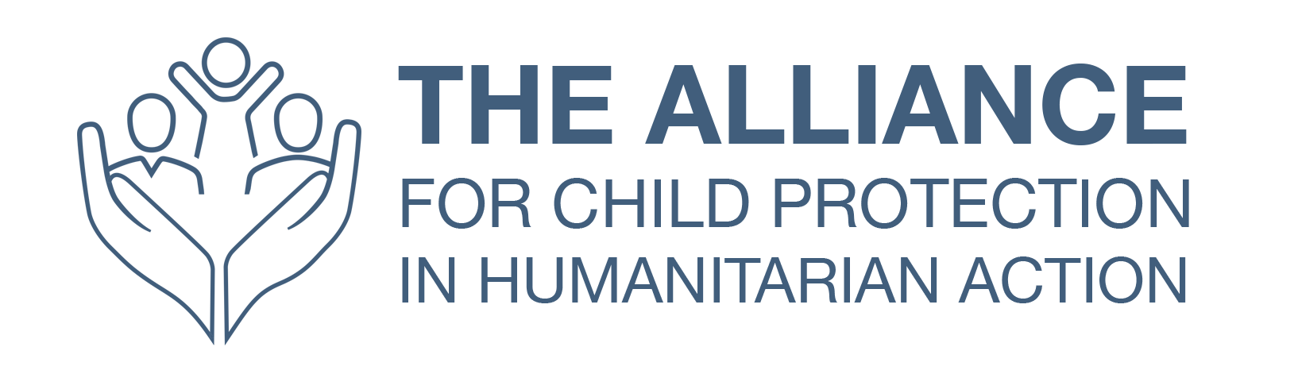

Terms of Reference – Translation of the Interagency Child Protection in Emergencies Training Packages –

Learning and Development Working Group (LDWG)

Location: Home based
- BACKGROUND
The Alliance's mission is to support the efforts of humanitarian actors to achieve high-quality and effective child protection interventions in humanitarian contexts, in both refugee and non-refugee settings. As a global network of operational agencies, academic institutions, policymakers, donors and practitioners, the Alliance facilitates inter-agency technical collaboration on child protection in all humanitarian contexts. It sets standards and produces technical guidance for use by the various stakeholders. The United Nations Children’s Fund (UNICEF) currently co-leads the Alliance with Save the Children.
The Alliance for Child Protection in Humanitarian Action facilitates inter-agency collaboration on normative work, including standard-setting and development of technical guidance. It also provides its members with technical support and guidance where needed. The Alliance’s work falls into five categories, one of which is:
- Capacity-building, learning and development: The Alliance develops technical capacity for child protection by identifying, expanding and strengthening the CPHA workforce; mapping capacity gaps; defining priorities and strategic direction for capacity development; and providing learning opportunities, both face-to-face and remote. The Capacity-building, learning and development work stream is a permanent work stream managed by the Learning and Development Working Group (LDWG). As a permanent work stream and given the extensive nature of the role of leading the LDWG it was agreed that the LDWG would have its own focal point to work with the LDWG leadership group and LDWG members to support the work plan.

The Learning and Development Working Group (LDWG) is focused on the learning and development objectives within the Alliance work plan for 2018-2020. The working group has the overall outcomes of bridging the human resource capacity and competence gaps for child protection in humanitarian action, by focusing on: increasing learning and development opportunities for CPHA actors at global, regional and national levels; developing and making accessible high quality learning material and supports for CPHA actors at all levels and across stages of emergencies; and ensuring CPHA professional, interagency developments and opportunities correspond with up to date capacity gaps, competencies and needs.

LDWG Work Plan Outcome 2018-2020:
“Bridging the Human Resource Capacity and Competence Gaps for Child Protection in Humanitarian Action.”
- Purpose
The overall goal of this consultancy is to support the L&D WG Focal Point in translating the F2F inter agency package from English to Spanish.

The F2F will require translation of the powerpoints, facilitators notes, and trainee materials. Specifically, this includes:
Modules that summarize core components of CPIE:
- Module 1: Module 1_Principles and Approaches to CPiE
- Module 2: Module 2_Ensuring a Quality CP Response
- Module 3: Module 3_Addressing Child Protection Needs
- Module 4: Module 4_Developing Child Protection Strategies
- Module 5: Module 5_Mainstreaming Child Protection
- Module 6: Module 6_Planning_Next Steps
- Optional Simulation_Plus 1 day
Key Resources:
- Agenda Samples
- Evaluation Forms_Daily_to be adapated
- Introduction
- Pre Learning and Survey_Sample
- Start and End Day Sessions
Participant Handouts
- Expected results & time frame
Expected results include the following, all in collaboration and close communication with the LDWG Focal Point:
- Compared analysis of already translated materials vs. newer version of the F2F: August 2019 (done by the LDWG Focal Point)
- Update of the already translated Spanish materials: 01 – 10 September 2019
- Translation of the remaining untranslated content: 10 – 30 September 2019
- Proof reading & Final editing: 01 – 15 October 2019

The Consultant will translate the following materials, per order of priorities:
Translation | Estimated Number of Words | Date Required
Modules
Module 1: Module 1_Principles and Approaches to CPiE | M1_S1_ 805 (w) + 252 (ppt) = 1057  M1_S2.PP5_: 720 (w) + 1132 (ppt) = 1852  M1_S3_ 359 (w) + 2541 (ppt) = 2900  M1_CPMS: 1447 (w) + 2100 (ppt) = 3547  M1_Cover: 259  TOTAL = 9615
Module 2: Module 2_Ensuring a Quality CP Response | M2_S1_1023 (w)+ 222(ppt) = 1245  Stands_ 1274  M2_S2_ 243 (w)+ 141 (ppt) = 384  M2_S2_Optional_230 (ppt) + 240 (ppt) + 1152 (w) + 1003 (ppt) + 2109 (w) + 160 (ppt) + 645 (ppt) + 102 (w) + 152 (w) = 5739  M2_S3_763 (w) + 391 (ppt) = 1154  M2_S4_ 665 (w) + 283 (ppt) = 948  M2_S5_2624 (w) + 3088 (ppt) = 5712  M2_S5_ Optional_1426 (ppt) + 817 (ppt) = 2243  M2_S6_136 (ppt)  M2_Cover_421 (w)  TOTAL = 19256
Module 3: Module 3_Addressing Child Protection Needs | M3_S1_236 (w) + 235 (ppt) = 471  M3_S2_134 (w) +183 (ppt) = 317  M3_S3_ 175 (w) + 715 (ppt) = 890  M3_S4_607 (ppt)  M3_S4_Optional_ 2764 (w) + 532 (ppt)= 3296  M3_S5_1342 (ppt)  M3_S5_Optional_3154 (ppt)  M3_S6_15526 (ppt) + 14034 (w) + 1754 (w)= 31314  M3_S7_ 1406 (ppt)  M3_S8_ 50 (ppt)  M3_All in one_5022 (ppt)  M3_Cover_502 (w)  TOTAL = 48371
Module 4: Module 4_Developing Child Protection Strategies | M4_S1_ 665 (w) + 1156 (ppt) = 1821  M4_S2_ 1494 (ppt)  M4_S3_ 337 (ppt) + 956 (ppt)= 1293  M4_S4_ 108 (ppt)  M4_Optional_ 481 (ppt) + 1537 (w) + 226 (w) + 247 (w)= 2491  M4_Cover_302 (w)  TOTAL = 7509
Module 5: Module 5_Mainstreaming Child Protection | M5_S1_1442 (w)  M5_S2_2769 (w)+ 220 (ppt) + 1395 (w)= 4384  M5_S3_2779 (w) +272 (ppt) + 1416 (w) = 4467  M5_S4_2237 (w) + 272 (ppt) + 822 (w) = 3331  M5_S5_ 2332 (w) + 272 (ppt) + 991 (w) = 3595  M5_S6_ 2039 (w) + 272 (ppt) + 658 (w) = 2969  M5_S7_ 942 (w)  M5_Optional _ 4757 (w) + 635 (ppt) = 5392  Extra _ 125 (ppt) + 795 (w)= 920  M5_Cover_ 182 (w)  TOTAL = 27624
Module 6: Module 6_Planning_Next Steps | M6_S1_186 (ppt)  M6_S2_121 (ppt)  M6_Optional_562 (ppt)  M6_Templates (w)_85+60+65+60+59+53+21=403  M6_Cover_ 179 (w)  TOTAL =1451
Optional Simulation_Plus 1 day | 104 (ppt) + 884 (w) + 665 (w) + 217(w) +698 (w)+ 477 (w)  TOTAL = 3045
Participant Handouts

Templates | 3436+ 1560+922+474+1980+2395+136
 | TOTAL = 10903
Key Resources
Agenda Samples | 2298 (W)
Pre Learning and Survey_Sample | 354 (pdf)
Evaluation Forms_Daily_to be adapated | 300 x 6 (word) = 1800
Introduction | 1255 (word) + 322 (ppt)= 1577
Introduction Activity Grab Bag | 171+158 + 90 + 128 + 149 (word) = 696  90 + 121+ 80+ 128+ 90+ 14 (ppt) = 523  TOTAL = 1219
Start and End Day Sessions | 57 (ppt)  416 (w) +103 (ppt)  3 (ppt)  328 (w) +51 (ppt) +325 (w)  3 (ppt)  86 (ppt)  3 (ppt)  3 (ppt)  TOTAL = 1378
CPIE F2F V2014 Training Cover Pack | 2076
GRAND TOTAL | 138.476

Deliverables will be approved by the L&D WG Focal Point. Translation should reference the CPMS content Spanish translation for appropriate terms and tone.
- Key competences, technical background, and experience required:
- Experience with IT tools and computer skills; especially Word and Powerpoint
- Capacity to proof-read documents
- Excellent organizational skills
- Excellent skills in written & spoken English / Spanish language, interpersonal communication at a distance and collaborative project management
- Autonomy & Attention to details

The Consultant will be paid a fee based on the rate per word.
- HOw to Apply
Qualified candidates are requested to submit CV to: learning@alliancecpha.org, specifying as email title: “Translation of IA CPiE Training Packages Application_ NAME”

As per the Alliance governance document, the NGO co-lead rotates every three years.

